Practical : 17

## Aim: Create a Web page and test the connectivity of your database with biodata form in exercise 1. If connected, display the message that connection with database is successful, and redirect the user to his homepage

First.aspx

<%@ Page Language="vb" AutoEventWireup="false" CodeBehind="First.aspx.vb" Inherits="Practical_17.First" %>

<!DOCTYPE html>

<html xmlns="http://www.w3.org/1999/xhtml">

<head runat="server">

<title></title>

</head>

<body>

<form id="form1" runat="server">

<div>

Name :

<asp:TextBox ID="txtName" runat="server" />

<br />

Enrollment :

<asp:TextBox ID="txtEnroll" runat="server" MaxLength="12" />

<br />

Password :

<asp:TextBox ID="txtPwd" runat="server" TextMode="Password" />

<br />

<asp:Button ID="submit" runat="server" Text="Submit" />

</div>

</form>

</body>

</html>

First.aspx.vb

Public Class First

Inherits System.Web.UI.Page

Protected Sub Page_Load(ByVal sender As Object, ByVal e As System.EventArgs) Handles Me.Load

End Sub

Protected Sub submit_Click(sender As Object, e As EventArgs) Handles submit.Click

Dim conCheck As String

Try

Dim con As New SqlClient.SqlConnection("Data Source=(LocalDB)\MSSQLLocalDB;AttachDbFilename=C:\Users\ISHAN\Desktop\First.mdf;Integrated Security=True;Connect Timeout=30")

con.Open()

conCheck = con.State = ConnectionState.Open

Catch ex As Exception

Response.Write("Connection Unsuccessful")

End Try

If conCheck = True Then

Response.Redirect("Home.aspx")

End If

End Sub

End Class

Home.aspx

<%@ Page Language="vb" AutoEventWireup="false" CodeBehind="Home.aspx.vb" Inherits="Practical_17.Home" %>

<!DOCTYPE html>

<html xmlns="http://www.w3.org/1999/xhtml">

<head runat="server">

<title></title>

</head>

<body>

<form id="form1" runat="server">

<div>

<asp:Label ID="lblGreet" runat="server" Text="Your Connection was Successful and You are Redirected to the Home Page" />

</div>

</form>

</body>

</html>

Database:

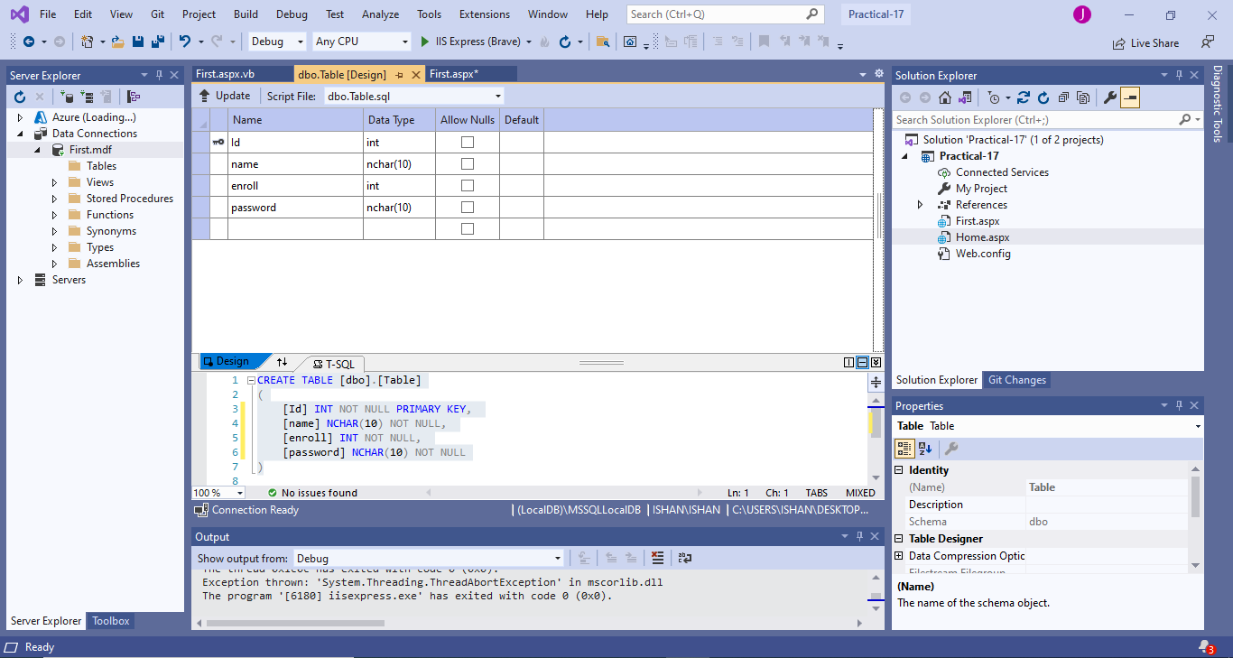

Output :

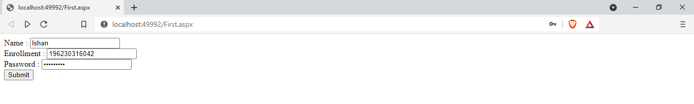



|  |  |  |  |
| --- | --- | --- | --- |
| Start Date | End/Sign Date | Faculty Sign | Remarks/Grade |
|  |  |  |  |

Practical : 18

## Aim: Create a login page in your web application. Login page must have user name and password fields. If user enters correct ID, Password, he must be redirected to the homepage of your website.

Login.aspx

<%@ Page Language="vb" AutoEventWireup="false" CodeBehind="Login.aspx.vb" Inherits="Practical_18.Login" %>

<!DOCTYPE html>

<html xmlns="http://www.w3.org/1999/xhtml">

<head runat="server">

<title></title>

</head>

<body>

<form id="form1" runat="server">

<div>

Username :

<asp:TextBox ID="txtUname" runat="server" />

<br />

<br />

Password :

<asp:TextBox ID="txtPwd" runat="server" TextMode="Password" />

<br />

<br />

<asp:Button ID="login" runat="server" Text="Login" OnClick="Login_Click" />

</div>

</form>

</body>

</html>

Login.aspx.vb

Imports System.Data.SqlClient

Public Class Login

Inherits System.Web.UI.Page

Protected Sub Page_Load(ByVal sender As Object, ByVal e As System.EventArgs) Handles Me.Load

End Sub

Protected Sub Login_Click(sender As Object, e As EventArgs) Handles login.Click

Dim con As New SqlClient.SqlConnection("Data Source=(LocalDB)\MSSQLLocalDB;AttachDbFilename=C:\Users\ISHAN\Desktop\students.mdf;Integrated Security=True;Connect Timeout=30")

Dim cmd As New SqlClient.SqlCommand("Select * from students where username = '" & txtUname.Text & "' and password= '" & txtPwd.Text & "'", con)

Dim ad As New SqlDataAdapter(cmd)

Dim ds As New DataSet

con.Open()

ad.Fill(ds)

con.Close()

If ds.Tables(0).Rows.Count > 0 Then

Response.Redirect("Home.aspx")

Else

Response.Write("Invalid Username or Password")

End If

End Sub

End Class

Home.aspx

<%@ Page Language="vb" AutoEventWireup="false" CodeBehind="Home.aspx.vb" Inherits="Practical_18.Home" %>

<!DOCTYPE html>

<html xmlns="http://www.w3.org/1999/xhtml">

<head runat="server">

<title></title>

</head>

<body>

<form id="form1" runat="server">

<div>

Login Was Successful and you are Redirected to Home Page

</div>

</form>

</body>

</html>

Database :

Database Format :

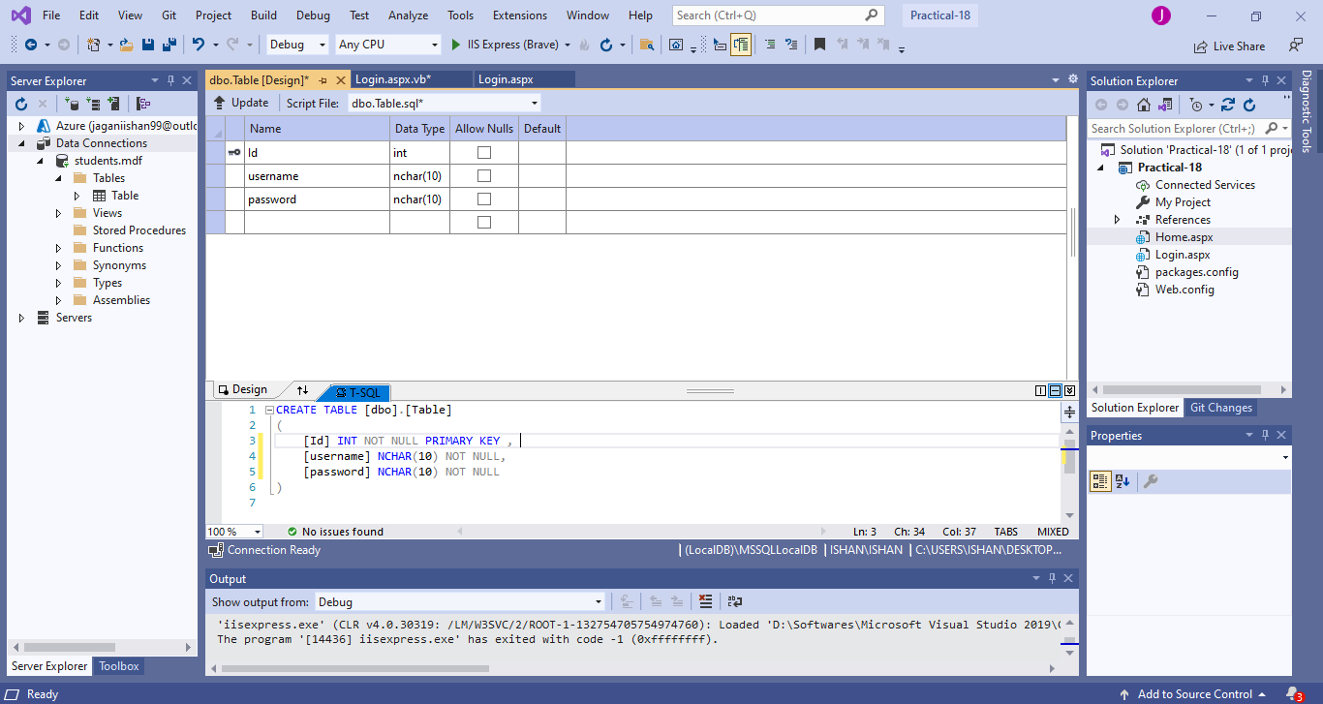

Records in Database :

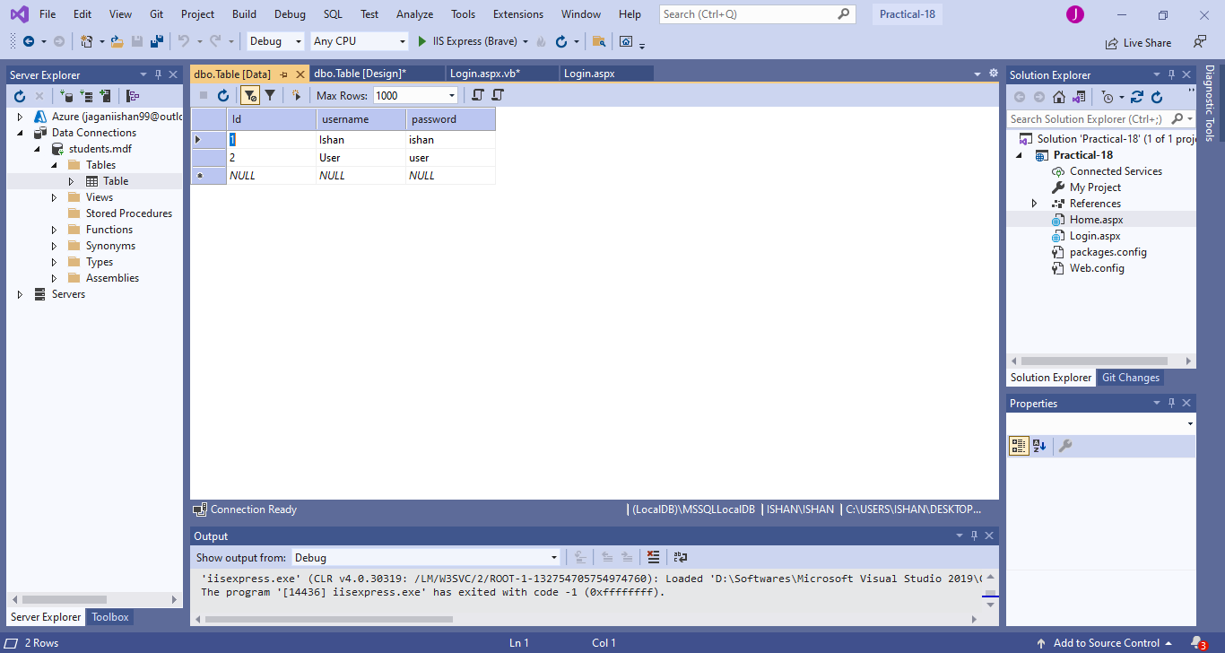

Output :

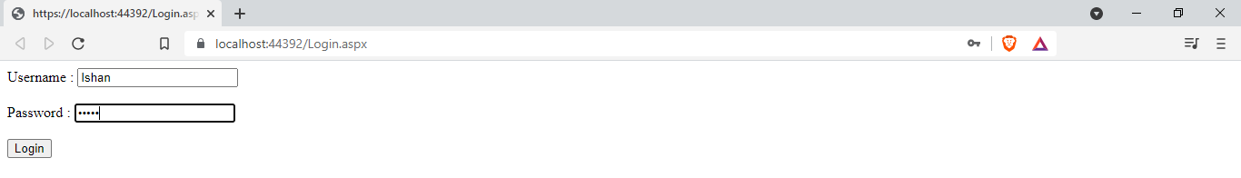



|  |  |  |  |
| --- | --- | --- | --- |
| Start Date | End/Sign Date | Faculty Sign | Remarks/Grade |
|  |  |  |  |

Practical : 19

## Aim: Create a web page to insert user biodata information with all validations in to the database

Form.aspx

<%@ Page Language="vb" AutoEventWireup="false" CodeBehind="Form.aspx.vb" Inherits="Practical_19.Form" %>

<!DOCTYPE html>

<html xmlns="http://www.w3.org/1999/xhtml">

<head runat="server">

<title></title>

</head>

<body>

<form id="form1" runat="server">

<div>

<strong>Bio-Data From</strong><br />

<br />

First Name : <asp:TextBox ID="txtfname" runat="server"></asp:TextBox>

<asp:RequiredFieldValidator ID="rfvFname" runat="server" ErrorMessage="*" ControlToValidate="txtfname" ForeColor="Red"></asp:RequiredFieldValidator>

<br />

<br />

Last Name :

<asp:TextBox ID="txtlname" runat="server"></asp:TextBox>

<asp:RequiredFieldValidator ID="rfvLname" runat="server" ErrorMessage="*" ControlToValidate="txtlname" ForeColor="Red"></asp:RequiredFieldValidator>

<br />

<br />

Age :

<asp:TextBox ID="txtAge" runat="server"></asp:TextBox>

<asp:RequiredFieldValidator ID="rfvAge" runat="server" ErrorMessage="*" ControlToValidate="txtAge" ForeColor="Red"></asp:RequiredFieldValidator>

<asp:RangeValidator ID="RangeValidator1" runat="server" ErrorMessage="Please Enter Valid Age !!" ControlToValidate="txtAge" Type="Integer" MaximumValue="100" MinimumValue="18" ForeColor="Red"></asp:RangeValidator>

<br />

<br />

Gender :&nbsp;

<asp:RadioButton ID="radMale" runat="server" GroupName="gender" Text="Male" />

<asp:RadioButton ID="radfemale" runat="server" GroupName="gender" Text="Female" />

<br />

<br />

Phone :

<asp:TextBox ID="txtPhone" runat="server"></asp:TextBox>

<asp:RequiredFieldValidator ID="rfvPhone" runat="server" ErrorMessage="*" ControlToValidate="txtPhone" ForeColor="Red"></asp:RequiredFieldValidator>

<br />

<br />

Qualification :

<asp:DropDownList ID="drpQualification" runat="server">

<asp:ListItem>Diploma</asp:ListItem>

<asp:ListItem>BE</asp:ListItem>

<asp:ListItem>Masters</asp:ListItem>

</asp:DropDownList>

<asp:RequiredFieldValidator ID="rfvQualification" runat="server" ErrorMessage="*" ControlToValidate="drpQualification" ForeColor="Red"></asp:RequiredFieldValidator>

<br />

<br />

<asp:Button ID="btnSubmit" runat="server" Text="Submit" />

<br />

<br />

<asp:Label ID="successLabel" runat="server" Text="" ForeColor="LightGreen"></asp:Label>

</div>

</form>

</body>

</html>

Form.aspx.vb

Public Class Form

Inherits System.Web.UI.Page

Protected Sub Page_Load(ByVal sender As Object, ByVal e As System.EventArgs) Handles Me.Load

End Sub

Protected Sub btnSubmit_Click1(sender As Object, e As EventArgs) Handles btnSubmit.Click

Dim qualification As String

Dim gender As String

Dim ans As Integer

If radMale.Checked Then

gender = "Male"

Else

gender = "Female"

End If

If drpQualification.SelectedIndex = 0 Then

qualification = "Diploma"

ElseIf drpQualification.SelectedIndex = 1 Then

qualification = "BE"

Else

qualification = "Masters"

End If

Dim con As New SqlClient.SqlConnection("Data Source=(LocalDB)\MSSQLLocalDB;AttachDbFilename=C:\Users\ISHAN\Desktop\Databases\biodata.mdf;Integrated Security=True;Connect Timeout=30")

Dim cmd As New SqlClient.SqlCommand("Insert into Table(fname,lname,gender,phone,qualification) values('" & txtfname.Text & "','" & txtlname.Text & "','" & gender & "','" & txtPhone.Text & "','" & qualification & "')", con)

con.Open()

cmd.ExecuteNonQuery()

con.Close()

successLabel.Text = "Data Added Successfully !!"

End Sub

End Class

Output :

Before Inserting :

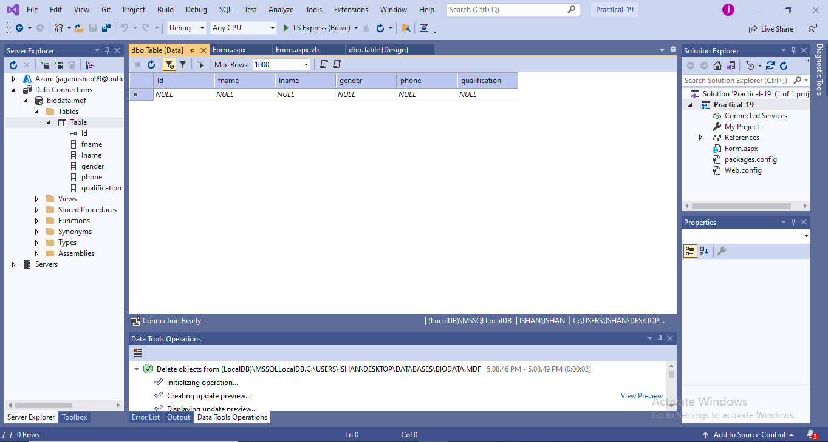

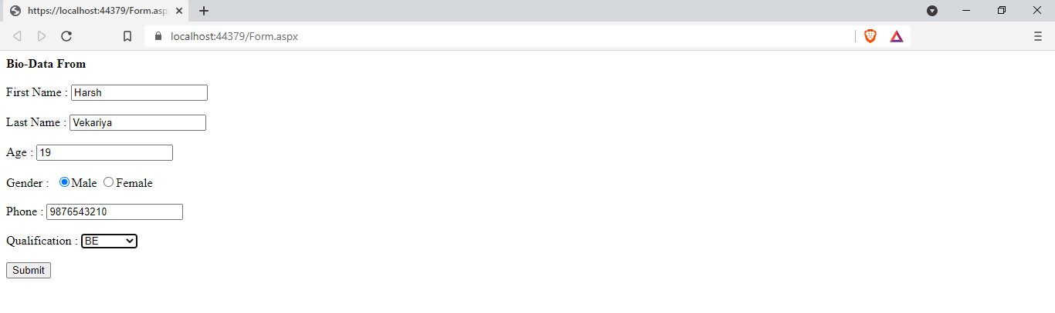

On Data Added Successfully :

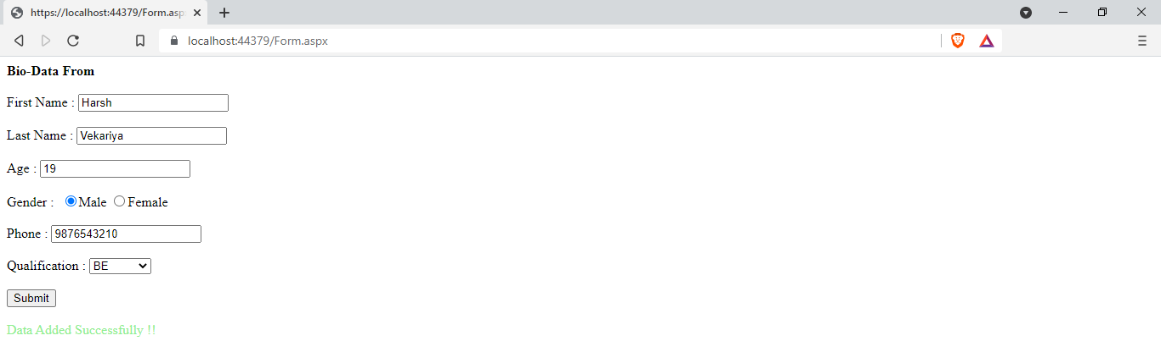

After Filling Form and Entering Data :

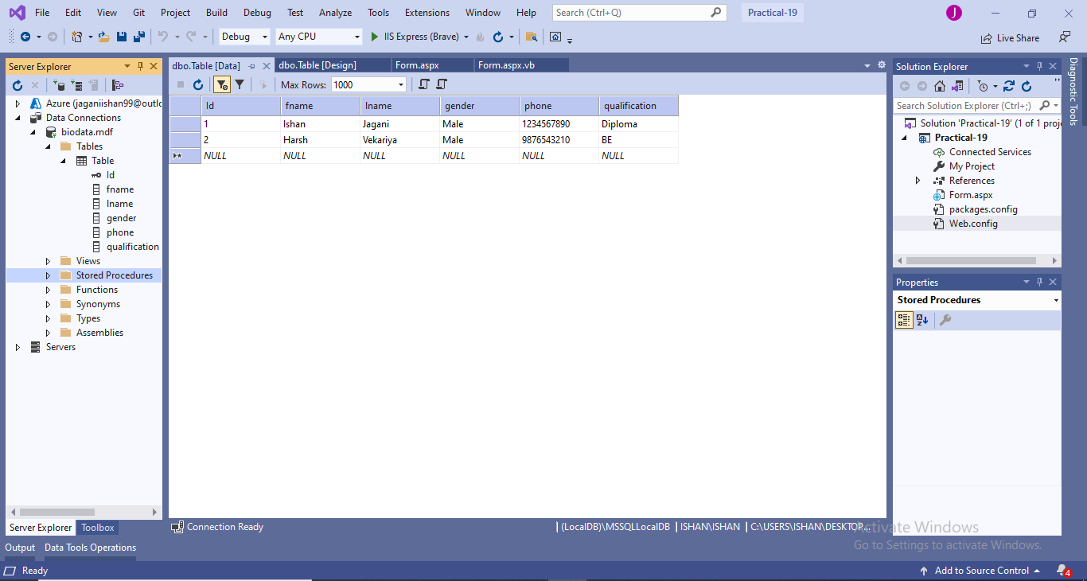

|  |  |  |  |
| --- | --- | --- | --- |
| Start Date | End/Sign Date | Faculty Sign | Remarks/Grade |
|  |  |  |  |